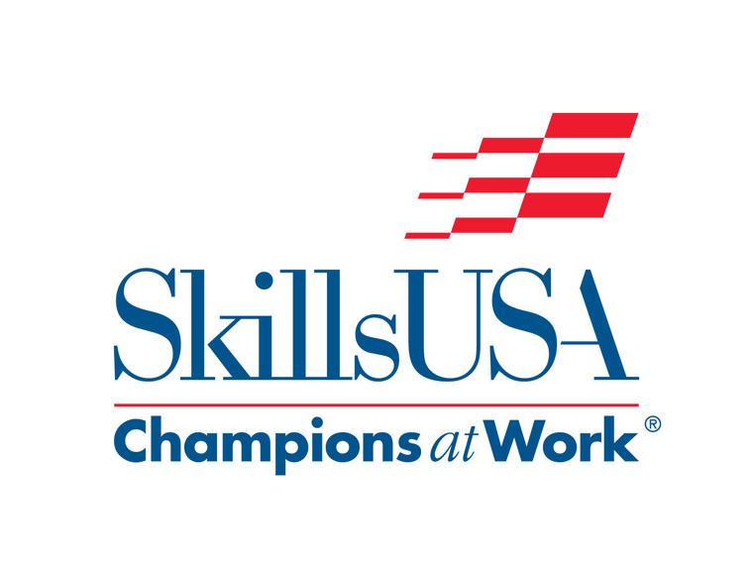

Contest Updates for NLSC 2018

Résumé Requirement
All competitors must create a one-page hard copy résumé and submit this to the technical committee chair at the contest orientation. Failure to do so will result in a 10 point penalty. Competitors can bring a résumé to the contest on the day of competition however, the penalty will remain in effect.

Clothing and Tools
SkillsUSA Championships Clothing and Tools App Updated
SkillsUSA has updated the “SkillsUSA: Clothing and Tools” app for 2018. This is a great starter resource that does not replace the SkillsUSA Championships Technical Standards but connects users to SkillsUSA’s membership site, where educators can join as professional members to receive the full standards at no charge.
For each contest, the app includes an overview, clothing requirements and eligibility and safety guidelines. It also lists the specific tools, equipment or materials that contestants must provide.
The app is offered free of charge for students, instructors and SkillsUSA business partners and is available available now in both the Apple Store: http://apple.co/2dtlb8d and the Google Play Store: http://bit.ly/2e5fRec. This app was created and sponsored by Pearson (www.pearsoned.com).

Contests with Specific Team Members
The contests below are the contests that had a change from various team members to a specific numbers/teams.
All members will be interviewed and or will be taking part in the contest. Some of the Technical Standards may state one member however they will all be scored and questioned to some extent.
American Spirit AM – 3
Chapter Display DIS – 3
Interactive Application and Video Game Development IAGD – 2
Occupational Health and Safety – Single: OHSS – 3
Occupational Health and Safety – Multiple: OHSM – 3
Outstanding Chapter OUT – 3
Promotional Bulletin Board: BB – 3

Leadership
Promotional Bulletin Board
The technical committee is going to increase the presentation time to 5-7 minutes. It was previously 3-5.

Skilled and Technical
Automated Manufacturing Technology
Please use the following link to access practice materials for the contest, a download link to the simulation software for the BenchMill 6100, software instructions, and other relevant and important information.
http://intelitekdownloads.com/skills/skills_cnc/index.htm

Automotive Refinishing Technology
The following PDF’s will assist you in preparing and study for spot repair.
Spot Repair
The PDF below has an example of the Color Tint Contestant worksheet.
Color Tint contestant worksheet sample
To better prepare, the following PDF will help the contestants study and understand Featheredge Prime and Block
Featheredge Prime and Block
4/21/18
The PDF below will help the contestants study and understand Color Tinting.
Color Tinting

Automotive Service Technology
There has been an update made to the AST contest description. (See revised PDF. Rev. C, below) The Special Tool Provided section has been updated in Station P4.
Automotive Service Technology with update
The Automotive Service Technology stations for both High School and College/Postsecondary are listed in the link below:
Automotive Service Technology Contest Stations

Collision Repair Technology
To help the competitors to be better prepared for this year’s contest the document below covers information on Plastic and Nitrogen Welding along with tips on metal repair.
Plastic and Nitrogen Welding
To help clarify the needed tools that the competitors need to bring please see the document below. It is the same as we have in the Technical Standards, it just clarifies no power tools are needed.
Tool requirements for Collision Repair Technology

Cosmetology
The schedule, the general review and mannequins that are going to be used are at the following link: www.pivot-point.com/connect/competitions/skills-usa

Culinary Arts
Attached is an additional info sheet for the Culinary Arts contest on stations and equipment.
Culinary Arts stations and equipment
The schedule and menus for High School and Postsecondary are in the document below:
Culinary Arts menus

Electrical Construction Wiring
Please see the attached document that explains what NEC Code book will be used at this year’s written test.
Electrical Construction Wiring

Esthetics
Due to some confusion on last year’s clothing, and some questions on product use, please see the document below:
Esthetics Contest Update
The Fantasy Makeup theme for 2018 Esthetics competitions is “Looney Tunes.”

Welding
Please note comments concerning the required tools that are needed and what is not allowed, the items supplied by the committee and the welding project.
Welding update

Welding Fabrication
For Welding Fabrication teams this year the project and set-up is slightly different. Please review the files below for clarification.
Welding Fabrication update

